**ICT Propulsion Block**

**Propulsion Block**

**Reinforcing Orderblock Theory**

[Propulsion Block]

I I

-

Ideal Set Up:

In Major To Intermediate Term Uptrends

**Bullish Propulsion Block** is a candle or bar that has previously traded down into a down candle or "Bullish Orderblock" & takes over the role of Price Support for higher Price movement.

I

That new higher orderblock will be highly sensitive, it should never see the mean threshold break, the 50% of the body. Most of the time it will trade back into the high of the candle and then immediately see a reaction, it explodes up.

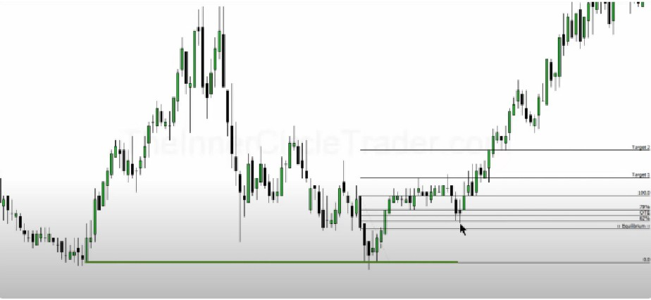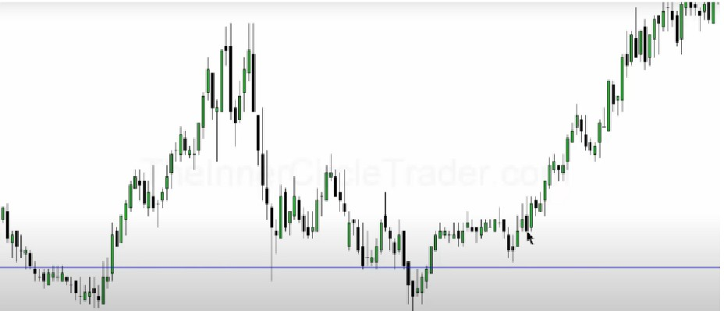

If it breaks the mean threshold of the propulsion block, chances are its not a good trade

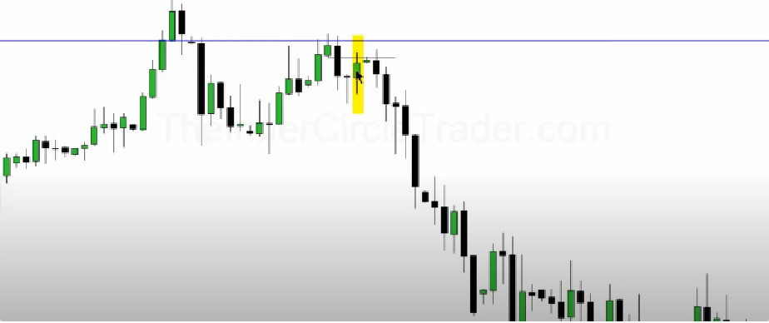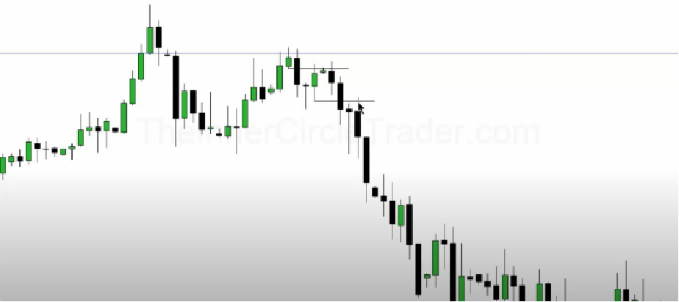

He uses the lowest wick here, so not the body

This gives you very little drawdown and immediate price response, it repulses price

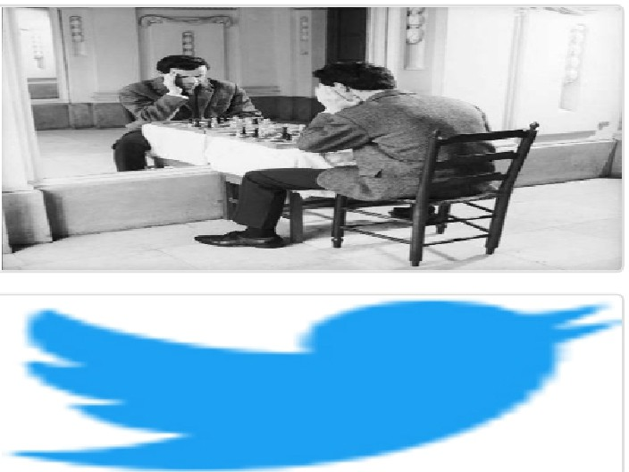Arjo I Twitter, lnstagram I Linktree

Linktree. Make your link do more. " https://t.co/HhmmTN1fUI

JavaScript is not available.

*'!I* https://twitter.com/arjoio